

**Effort: 20 mins**

Objective

In this lab, you will learn:

1. Import a Jupyter notebook in a Watson Studio Project
2. Perform the tasks in the Jupyter notebook

Pre-requisite: IBM Watson Setup

*If you have not created a Watson service and added a project in it, before proceeding with this lab please ensure you complete the previous lab: [https://cf-courses-data.s3.us.cloud-object-storage.appdomain.cloud/IBMDeveloperSkillsNetwork-PY0101EN-SkillsNetwork/labs/FinalModule\_Coursera/IBM\_Cloud\_and\_Watson\_Setup.md.html](https://cf-courses-data.s3.us.cloud-object-storage.appdomain.cloud/IBMDeveloperSkillsNetwork-PY0101EN-SkillsNetwork/labs/FinalModule_Coursera/IBM_Cloud_and_Watson_Setup.md.html" \t "_blank)*

Step 1: Adding a Notebook to the Project:

You need to add a Notebook to your project. Click **Add to project.**

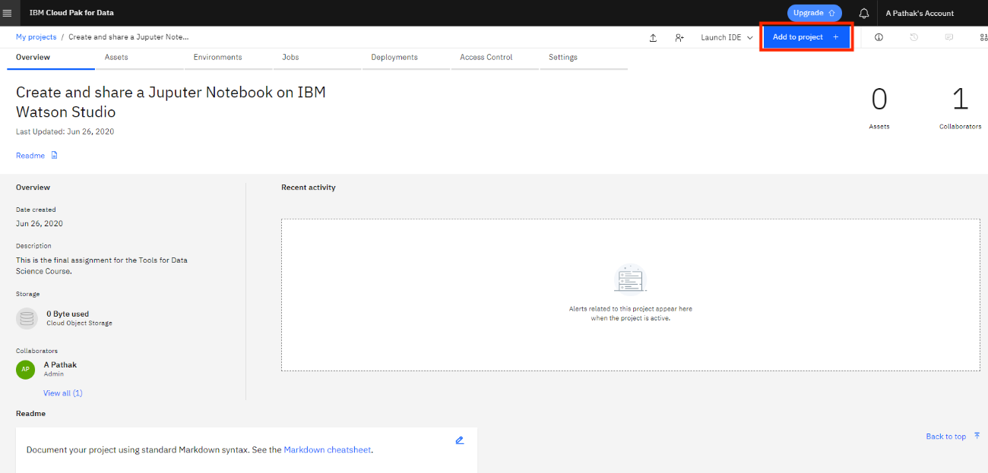

In the list of asset types, click **Notebook:**

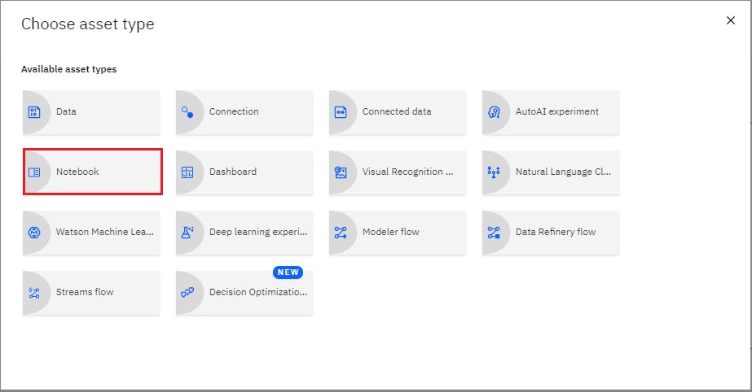

Note: Select the default Python as selected language.

On the New Notebook page, enter a name for the notebook, and then click From URL.

Paste the URL you copied from the previous reading in the course into the **Notebook URL** box, and then click **Create Notebook**.

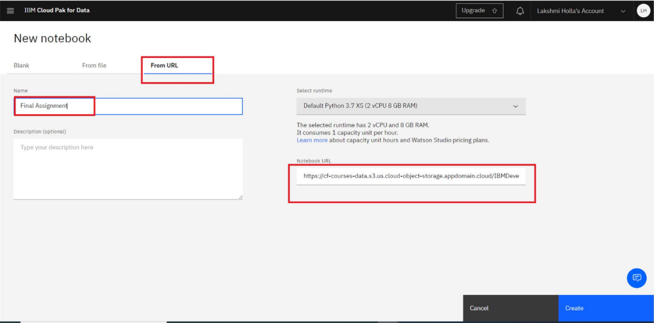

You will see a Notebook like this (the actual notebook may be different from the one shown in the screenshot below):

